**Word Press Plug-in: Display Top 10 Posts Widget**

**Instructions:**

1. Copy the “DisplayTop10PostsWidgets” to word press plug-in directory (“Install_Folder/wordpress/wp-content/plugins”)
2. Login to Wordpress Admin (localhost/wordpress/wp-admin)

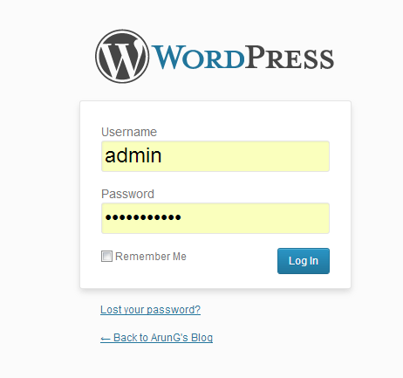

1. The Admin site for your Word Press blog will open. Click on the Plugins->Installed Plugins

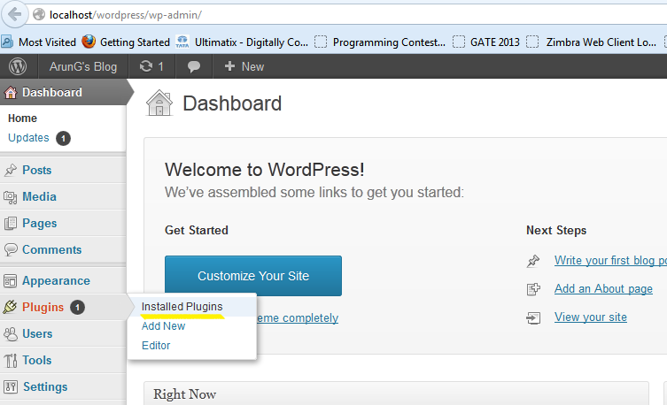

1. The Plug-in ‘Display Top 10 Posts Widget’ will be displayed. Click on the Activate link.

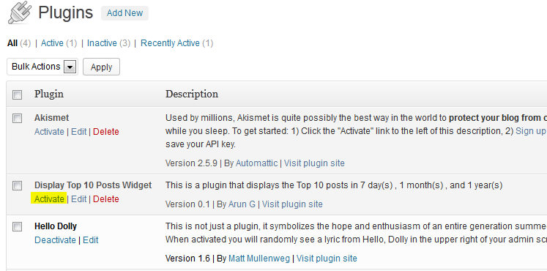

1. Plug-in Activated will be displayed.

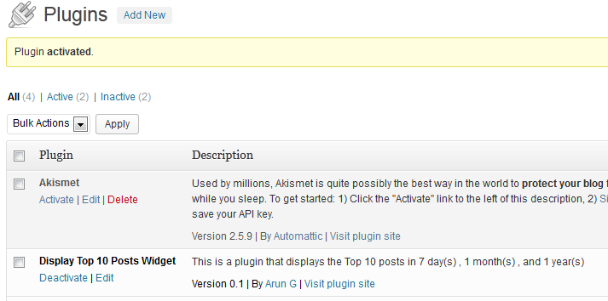

1. Now go to the Widgets by clicking on Appearance-> Widgets.

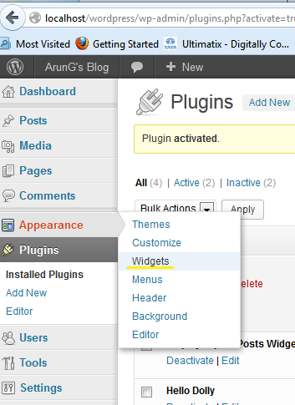

1. Now Drag and drop the Widget from the ‘Available Widgets’ to the ‘Main Side Bar’

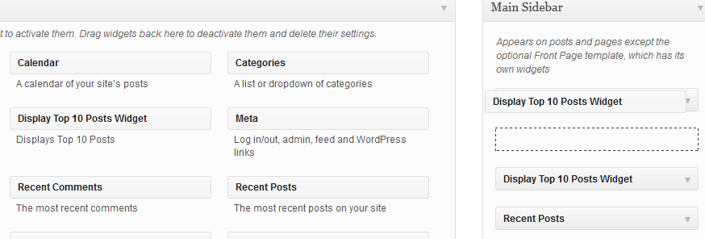

1. Now fill the required settings (Google Analytics Email, Google Analytics Password, Google Analytics Profile Id, Max Results and Time Duration) and click save.

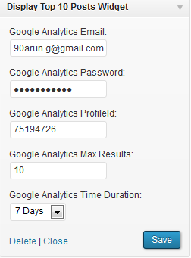

1. You can drag and drop the widget how many times you want and configure for different Durations.
2. Next Open a word press page and the Widget will display the top 10 posts based on duration.

Please find the screen shot below:

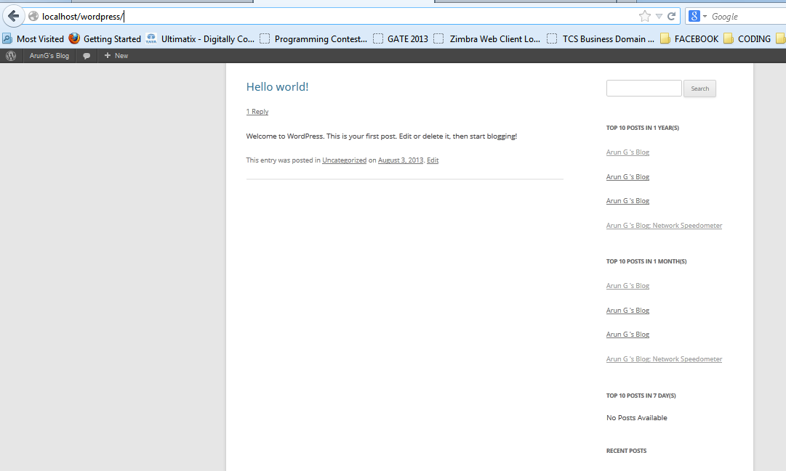

**Common Help:**

1. If the Widget displays “**No Posts Available**” it means no analytics data was returned for the particular time duration.
2. If the Widget displays “**Could not get Report Data. Error Occurred. Please verify the settings are right**” it means there is something wrong with the settings
3. Verify whether Gmail account is right
4. Verify whether password is right
5. Verify whether Profile Id is right. (profile id will be in the form of 8 digits)